1. **Exploratory of variables** ( Q1 )

Figure 1.1. The statistical summary of the dataset

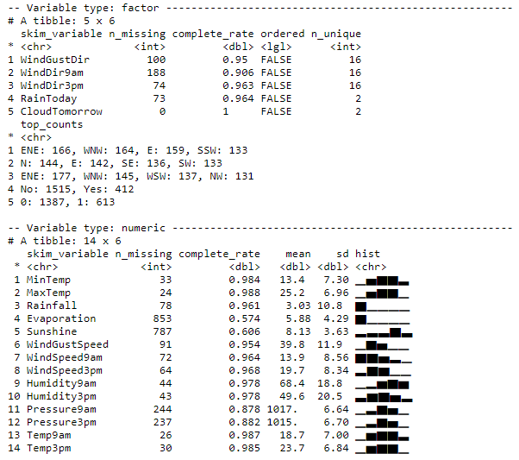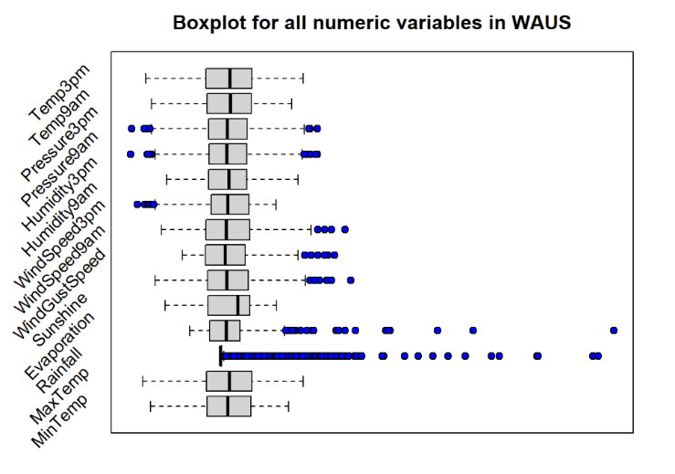

Figure 1.2. The boxplot of the dataset

Based on the statistical summary of the dataset (Figure 1.1), there are serveral noteworthy insights explained below:

* The proportion of cloudy days to clear days is 30.65% (Cloudy =1387, Not Cloudy = 613).
* The mean of Pressure9am and Pressure3pm are notably high.
* Most of the variables are skewed. For example, Rainfall and Evaporation are extremely right-skewed. That shows that its median is larger than its mean. Contrariwise, Humidity9am and Sunshine are left-skewed.­
* A majority of variables contain NA values. Especisally, Evaporation and Sunshine have 43% and 39% missing values.
* Since this analysis is predicting whether the following day will be cloudy, some variables are not essential to be predictors, namely Day, Month, and Year; hence they are omitted.

On top of the insights, based on (Figure 1.2), Rainfall is the most extreme variable as it has the highest range and abundant outliers. Few variables like Temp3pm and MaxTemp are of similar distribution.

**2. Data Cleaning and Pre-processing** ( Q 2,3 )

Before modelling, the data pre-processing should be conducted which is gleaned from the part 1 statistical summary.

**2.1. Dealing with Categorical values**

The data type of multiple variables is “Char” which is specified to be categorical. Using as.factor ( ) can categorise the variables of all wind direction, RainToday, location, and CloudTomorrow.

**2.2. Handling missing values and outliers**

All rows with NA values are removed, as a compromise between complexity for modelling and information loss. Generally, it is assumed that these data points are missing at random (MAR), meaning that the tendency for a data point to be missing is not related to the missing data. The cause perhaps was due to human errors during data collection, or some points of sensors functioned improperly on those days that weather cannot be detected. Moreover, the analysis involves the comparison between models. Some of the classifiers like Boosting and ANN cannot handle missing values while others can. This context must be ensured that the dataset is consistent when comparing models, therefore, removing missing values is necessary.

Furthermore, since all models are robust to outliers, they are not removed.

**2.3. Data Splicing**

At this stage, the dataset is cleaned and ready to model. The dataset is split into 70% for training and 30% for testing, with a random seed set as 31084222.

**3. The comparison of the original models** ( Q 4,5,6,7 )

The following is the code for five classifiers, all of which are at their default settings.

#Decision Tree

tree.train = tree( CloudTomorrow ~ ., data=WAUS.train )

#Naïve Bayes

NB.train = naiveBayes( CloudTomorrow~.,data=WAUS.train )

#Bagging

bag.train = bagging( CloudTomorrow ~. ,data = WAUS.train, mfinal = **6** )

#Boosting

boosting.train = boosting( CloudTomorrow ~. ,data = WAUS.train, mfinal = **7** )

#Random Forest

rf.train = randomForest( CloudTomorrow ~. ,data = WAUS.train )

*Assumption for the Naïve Bayes model:* Naïve means that all variables are independent; however, since this can hardly be achieved in real life. Therefore, it is assumed that all variables are independent.

After testing each model, Random Forrest (RF) is the best model. The reasons are explained below:

Firstly, although the accuracy is lower than Naïve Bayes model, the difference is minor, and the value for RF is sufficiently high (Figure 3.1). That means there is 70 % for RF to classify if tomorrow is cloudy or not cloudy correctly. Other values also are higher than other models overall.

Figure 3.1. The summary of the performance for the models

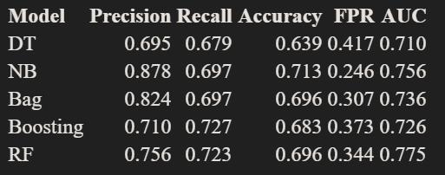

Secondly, AUC is where the best model was differentiated. Even though the accuracy of Bagging and RF is the same, the AUCs are different. That is, the dataset is biased towards “Cloudy” or “Not Cloudy”; Bagging might discriminate well on either side but RF tends to perform well overall. AUC is the proof of this case since it is an evaluation of the classifiers as thresholds vary over all possible values, of which RF rates comparatively higher than others. The cause might be that by partitioning the sample and randomly choosing the variables to model subtrees, the samples are more enriched, thus avoiding biases.

Figure 3.2. The ROC curves by classifiers

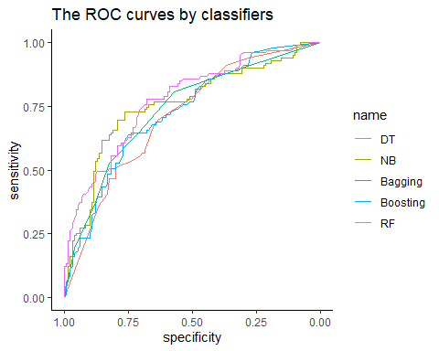

­

**4. The variable importance** ( Q8 )

Only Humidity3pm, MinTemp, Sunshine, WinDir3pm, WinDir9am and WinGustDir could be selected from the data because they are of higher effect on performance. The way the features are selected is based on the Gini index, which is a measure of variance; the higher the variance signifies the more misclassification exists, thus driving the values of Gini Index higher.In this scenario, ensemble methods like Bagging, Boosting and, Random Forrest are used to determine the variable importance.

Figure 4.1. The importance of each variable by classifiers

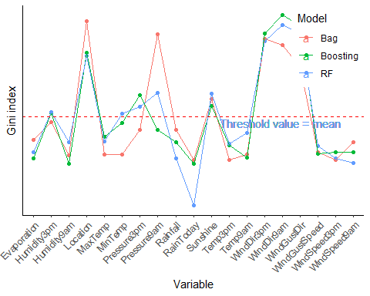

The reason I do not use Naïve bayse and other classifiers to select features is that their variables are of equal weighting. Whereas methods like Boosting are more suitable as their task is to reduce the variance error; they analyse different subsets of data and generate a collective output at the end. Since Boosting weighs its variables from the bags, it is particularly useful. Therefore, variable importance is based on ensemble methods.

Three models follow similar patterns on weighing its variables. Hence, I set the threshold value to the mean (Figure 4.3). Only features higher than the mean, could they be selected, which yields better classification.

**5.1. Evaluation of the improved model based on simplicity** ( Q9)

A decision tree is a simple classifier for a person to classify if it will be cloudy or not tomorrow.

**5.1.1. Feature selection:**

The conditions of being windy, cold, sunny, and high pressure are the four main factors affecting the decision of the class, all of which are based on the mentioned important variables. For the sake of simplicity in modelling, all predictor variables are categorical. Therefore, threshold values are set to determine the level of those conditions, which are listed below:

*1. Pressure is high if “Pressure3pm” and “Pressure9am” > 1013. (Standard average pressure)*

*2. It is cold when “MinTemp” < 10.*

*3. It is sunny if the hours of “Sunshine” > 12.*

*4. It is windy if the “WindSpeed3pm” and “WindSpeed9am” > 15*

**5.1.2. The process of modelling:**



* 1. *15 Rows were sampled from the WAUS.Train for training the model.*



*1.2. 5 Rows were sampled from the WAUS.Test for testing the model*

1. *Calculate the entropy of the Initial State. *
2. *Calculate the Information Gain for each predictor variable.*



Table 3.1. Information gain: Cold



Table 3.2. Information gain: Pressure



Table 3.3. Information gain: Sunshine



From the tables above, “Sunshine” has the greatest information gain, thus becoming the root node.

* 1. *Split the attributes for the next branches.*

*Note* : Since the following parts of calculation conforms the same to the above steps, so from the next ones are skipped.

Gain( Not Sunny, Windy )=0.2212

Gain( Not Sunny, Cold )=0.0968

Gain( Not Sunny, Pressure )=0.0642

The above are the values of information gain for each variable given that the day is not sunny. “Windy” has the highest value, therefore it is the node when the day is not sunny.

Gain ( Sunny, Windy )=0.9710

Gain ( Sunny, Cold )=0.9710

Gain ( Sunny, Pressure )=0.9710

Likewise, the above are the values of information gain given that the day is sunny. Since one can observe that all values are the same, therefore, the algorithm will select the feature randomly, in which “Pressure” is selected as a node when the day is sunny.

* 1. *Split the attribute for the next branches.*

Gain ( Not Windy, Cold ) = 0.4553

Gain ( Windy, Cold ) = 0.4200

Since the value for “Cold” given that it is not windy is larger, the node of cold will be selected when it is not sunny and not windy.

**According the above steps, the model is generated as below :**

The accuracy of the model = ( 1+2 ) / ( 5 ) = 0.6

The recall of the model = ( 1 ) / ( 2+1 ) = 0.3

Although the accuracy of this model is merely different than other classifiers, that does not necessarily indicate that this model is good. Given the limited number of the training dataset, this model can be highly biased. Perhaps it is the randomness of the testing set that drives this accuracy to 60 % in classifying the label. Likewise, the label of the training set is mostly “Not Cloudy” and “Not Sunny”. That is, this model produces many false negative result, given that the Recall rate and AUC could be very low. Hence, this model cannot perform better than other classifiers.

**5.2. Evaluation of the improved model based on performance** ( Q10 )

As Random Forrest is the best model, it is used to optimise so as to get the best performance. The accuracy went up from .69 to .72 whereas AUC remained the same.

It is improved by adjusting the optimal parameters using trial and error, with the code shown below.

rf.train = randomForest(CloudTomorrow ~. ,data = df.improved.train,

ntree = 50000, importance = T, mtry = 2, nodesize = 42)

Importance = T was adjusted so that the importance of predictors could be assessed. Removing the low-important features could decrease the time complexity of the algorithm. Also, it increases the accuracy by reducing the variance.

mtry = 2 was to tune the number of predictors sampled for splitting the trees from 4 to 2. Since RF’s terminal nodes of each tree could be very small.

ntree = 50000 was to increase the number of trees

nodesize = 42 was to tune the minimum size of terminal nodes

*Note : The reason why Cross-validation was not used was that it utilised too many computational resources to increase .1 in accuracy with lower AUC, which is not worthy.*

This model is found to be the best in terms of time complexity and performance. By setting up more trees produces higher accuracy at the expense of slower learning. When realising this trade-off, some parameters above are to balance the runtime, so that the time complexity would not perform beyond the one at default setting. For example, setting the node size larger makes trees smaller to be grown, thus taking less time. And waiving the low-important variables can also achieve this purpose. For these reasons, tunning the parameters allows the model to achieve higher accuracy meanwhile running at the similar efficiency to the RF at default setting.

**6. Artificial Neural Network classifier** ( Q11 )

The features are selected based on the measures done in part 4. Through trial and error for modelling ANN, it is concluded that the variables of the best model are all categorical, all of which are converted to binary columns. This means that scaling is not needed. In addition, as mentioned above, all the rows with missing values were already removed for model comparison; therefore, this step can be skipped.

nn <- neuralnet(CloudTomorrow0 + CloudTomorrow1 ~ . ,data = nn.train[,],

hidden = 3, linear.output = F, threshold=0.01)

**6.1. This comparison between ANN and other classifiers**

The performance of ANN does not result as great as other classifiers. Its accuracy is only .513 and AUC is .572. As shown in the ROC curve, with most of the points lying towards the centre “abline”, ANN (Pink) does not perform as well as other classifiers, which indicates that lots of classes are labelled at random.

Generally, there are two reasons, in the aspects of dataset and fundamental.

*The model is overfitting and has high variance:* 2000 samples are not sufficient for a complex model like ANN to fit. ANN is considered a data-hungry model which entails millions of samples to form a big network in which its performance is strongly depended on the level of noise and richness of the dataset. However, in this case, if the samples were increased, then the trade-off is that it would be incomparable to other classifiers, since feeding different size of datasets to different models would draw an arbitrary conclusion.

*ANN model does not suit for solving this problem:* Evidently, no matter how much learning rate and thresholds the ANN were altered in the parameter, after trial and error, the performance remained the same. That is, the model does not classify well if tomorrow is cloudy or not. The nature of problem defines which models to use. There is no the “perfect” classifier for solving all problems. As shown in the ROC curve, the only way is to implement every possible classifier that could work on the dataset, and then decide which model perform best for the problem. ANN is known to solve complex problems like image recognition but not the other ones. So, it is rational to infer that the model might not suit well due to the nature of problem.

**Appendix**

The code of this assignment is shown from the next page.

If codes from the next page is found to be invalid, please go to the link below for downloading the R markdown files:

https://github.com/JasonXsiu/FIT3152asm2